**CHAPTER 4: RESEARCH RESULTS**

**4.1 Introduction**

In chapter 3 the research methods and instruments used for collecting data for this study were discussed. This chapter presents the results of stakeholders in construction industry particularly road sector in Tanzania. The data were obtained through a questionnaire on Design and Build procurement system. Therefore, this chapter present the results of the questionnaire and interpretation will be covered in Chapter 5 of this Study. The outline of chapter four is as follows:

* A summary of biodata of the respondents
* The results of the data collected for the different sections. They are grouped into issues that are deemed suitable to address the research objectives in the next chapter.
* Current practice of Design and Build procurement system on road works
* Challenges of Traditional procurement system
* Barriers of shifting from Traditional procurement system to Design and Build procurement system
* Controlling costs escalation by using Design and Build procurement system on road works

The survey questionnaire was administered to the respondents by using an online google forms. The online questionnaire enabled each respondent to complete the questionnaire electronically in full and independent of each other. This questionnaire was accompanied by covering letter, describing the purpose of the research. It also described how the results are used and ensure confidentiality of respondents. This helped in eliminating doubt and question that respondents may have had. The respondents were given four weeks to complete the questionnaire. After closing date all responses were gathered to prepare a summary of the research findings.

**4.1. Composition of Respondents**

Table 4.1 provides a brief profile of the people who responded to the questionnaire. The respondent were also asked to identify their professional, age, current job position and experience in construction industry. Furthermore, they were asked if they have ever used Design and Build procurement system in their whole period engaged in construction sector.

Table 4.1: Respondents Profiles

|  |  |  |  |
| --- | --- | --- | --- |
| **Respondents** | **Discipline** | **Positions** | **Roles and Responsibilities** |
| A | Clients | Project Managers  Project Engineers  Senior Quantity Surveyors  Project Quantity Surveyors |  |
| B | Consultants | Project Managers  Project Engineers  Senior Quantity Surveyors  Project Quantity Surveyors |  |
| C | Contractors | Project Managers  Project Engineers  Senior Quantity Surveyors  Project Quantity Surveyors |  |

Table 4.2 shows a breakdown of the population (total of Clients, Consultants and Contractors), and percentage of group that questionnaire was sent to and a percentage of those who responded. Of the 150 questionnaires sent to different groups in the construction sector, about 40 percent (60 people) responded (Table 4.2). The contribution of each construction group is presented in figure 4.1. Among 60 respondents 21(14%) were Clients, 21(14%) were professional Consultants and 18 (12%) were Contractors.

**4.1.1 Composition of Respondents (Composition by discipline)**

**Table 4.2: Summary of Respondents**

|  |  |  |  |
| --- | --- | --- | --- |
| Respondent | Targeted Count | Responded  Count | Response Rate (percentage) |
| Clients | 50 | 21 | 14 |
| Consultants | 50 | 21 | 14 |
| Contractors | 50 | 18 | 12 |
| Total | 150 | 60 | 40 |

FIGURE 4.1: A bar chart showing contribution of each construction group

**4.1.2 Composition of respondents by age profile**

Respondents were asked in questionnaire to indicate their respective age bracket in which they fall. Table 4.3 summarize the number of respondents with reference to their age group. The majority of the respondents comprise 43.3% (n =26) aged between 31 and 35 years (Table 4.3). This was followed by respondents with age between 36-40 (18.3%), above 45 (16.7%), below 31 (11.7%) and respondents with age between 41-45 had the lowest percentage (10%). The above composition has been graphically presented in for more clarity in a bar chart as illustrated in a figure below 4.2 below

**Table 4.3: Age Profile**

|  |  |  |
| --- | --- | --- |
| Range | Number | % Respondents |
| Below 31 | 7 | 11.7% |
| 31 - 35 | 26 | 43.3% |
| 36 - 40 | 11 | 18.3% |
| 41 - 45 | 6 | 10% |
| Above 45 | 6 | 16.7% |

FIGURE 4.2: A bar chart showing age group

**4.1.3 Composition of respondents by experience in the Construction Industry**

Table 4.4 shows experience of respondents in Construction Industry. Respondents had extensive experience in the construction industry of which 31.7% (n =19) had worked in the industry for between 6 and 9 years. This is followed by respondents with 3-5 year experience (28.3%), followed by respondents with 10-15 year experience (18.3%), respondents with less than 3years experience (13.3%). Respondents above 15 year experience contributed 8.3% only (Table 4.4). Figure 4.4 illustrates this composition further.

**Table 4.4: Experience of Respondents**

|  |  |  |
| --- | --- | --- |
| **Range (Years)** | **Frequency** | **Percentage of respondents** |
| Less than 3 yrs | 8 | 13.3 |
| 3 - 5 | 17 | 28.3 |
| 6 - 9 | 19 | 31.7 |
| 10-15 | 11 | 18.3 |
| Above 15 | 5 | 8.3 |

Figure 4.3: A bar chart showing experience of respondents

**4.1.3 Composition by familiarity with Design and Build procurement system**

Table 4.5 shows familiarity of respondents to use Design and Build procurement system. Of 60 respondents, a good number of 77% are familiar with Design and Build procurement system and 23% are unfamiliar with the system (Table 4.5).

Table 4.5: Shows familiarity with Design and Build Procurement System

|  |  |  |
| --- | --- | --- |
| **Co. has used D&B procurement system** | **Number of respondent** | **% Respondents** |
| Yes | 46 | 76.7% |
| No | 14 | 23.3% |
| **Total** | **60** | **100%** |

Of 60 respondents, 53% are using the system full time and only 32% use it occasionally (Table 4.6). 15% never answered the question.

|  |  |  |
| --- | --- | --- |
| **Co. has used D&B procurement system** | **Number of respondent** | **Respondents** |
| In full | 32 | 53 |
| In part | 19 | 32 |
| N/A | 9 | 15 |
| **Total** | **51** | **100** |

Professional Consultants, Clients and Contractors who have used the D&B procurement system constitute 76.7% (n =46) of the total respondents that responded to this question.

Professional Consultants, Clients and Contractors who have partially used D&B constitute to 37.3% (n =19) of the total disciplines that responded to the questionnaire. 32 Only a total of 62.7% (n =32) confirmed to have used Design and Build procurement system in full. The above composition has been graphically presented in for more clarity in a pie chart as illustrated in a figure below 4.2 below:-

PIE CHART

**4.2 Presentation of Findings - Current of Design and Build Procurement System on roadwork projects in Tanzania**

The second part of the questionnaire consisting of five questions aimed at measure the current practice of Design and Build procurement system on roadwork projects in Tanzania. The questionnaire was drawn by using Likert scale using a rating of "1" to "4" where 1 means Strongly Disagree, 2 means Disagree, 3 means Agree and 4 means Strongly Agree. The following current practise of Design and Build procurement system were received for 60 valid responses as indicated in Table 4.7 below:-

|  |  |  |  |  |  |
| --- | --- | --- | --- | --- | --- |
| S/no. |  | **Strongly disagree**  **1** | **Disagree**  **2** | **Agree**  **3** | **Strongly agree**  **4** |
| 1. | It provides single point of contact between the Client and Contractor hence unsure the efficient utilization of resources on projects | 1 | 8 | 36 | 13 |
| 2. | It ensures certainty of final project cost to be high | 10 | 24 | 15 | 10 |
| 3. | It ensures project management efficiency is improved due to improved communication | 2 | 7 | 32 | 17 |
| 4. | It increases effectiveness and efficiency as the structure of the organization is simple | 3 | 9 | 29 | 17 |
| 5. | It ensures the designing and construction risks are transferred to the Contractor hence improve performance standards | 1 | 9 | 23 | 25 |

The above-outlined responses has further been graphically presented for clarity in a bar charts as illustrated in Figure 4.3a and b below:

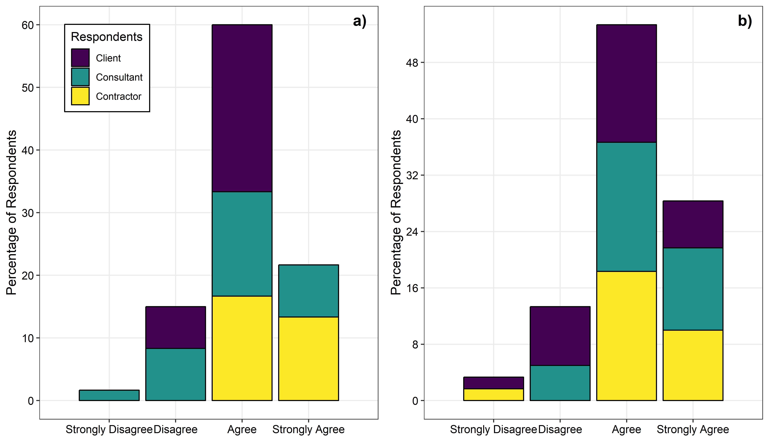

Figure 4.3

From Table 4.7 and figures 4.3 & 4.4 above the following observation are made:

* ….% (n=49) Professional Consultant, Client and Contractor agreed that provides single point of contact between the Client and Contractor hence ensure the efficient utilization of resources on projects. On the Contrary…..% (n=9) disagree.
* ….% (n=25) Professional Consultant, Client and Contractor agreed that Design and Build procurement system ensures certainty of final project cost to be high. On the Contrary….% (n=34) disagree.
* ……% (n=49) Professional Consultant, Client and Contractor agreed that Design and Build procurement system ensures project management efficiency is improved due to improved communication. On the Contrary….% (n=9) disagree.
* ……% (n=46) Professional Consultant, Client and Contractor agreed that Design and Build procurement system increases effectiveness and efficiency as the structure of the organization is simple. On the Contrary…..% (n=12) disagree.
* …..% (n=48) Professional Consultant, Client and Contractor agreed that Design and Build procurement system ensures the designing and construction risks are transferred to the Contractor hence improve performance standards. On the Contrary….% (n=10) disagree.

**4.3 Presentation of Findings - challenges caused by traditional procurement system on roadworks project in Tanzania**

The second issue addressed by the questionnaire was to determine the challenges caused by traditional procurement system on roadworks project in Tanzania. Section C has nine statements aimed at providing data to answer this Research Question. Their responses were recorded in Table 4.8 as shown below:-

|  |  |  |  |  |  |  |  |  |  |
| --- | --- | --- | --- | --- | --- | --- | --- | --- | --- |
|  | **Challenges of traditional procurement system on roadworks** | **How do you feel the following are challenges of traditional procurement system (Expectations)** | | | | **How do you rate the performance of traditional procurement system (Perceptions)** | | | |
| **S/No.** |
|  |  | Unimportant | | | Important | L |  |  | H |
| 1 | TP does not ensure cost certainty to the owner | Strongly disagree | disagree | agree | Stronlgy agree | Strongly disagree | disagree | agree | Strongly agree |
|  | 6 | 8 | 26 | 18 | 5 | 7 | 19 | 24 |
| 2 | Completion date is not rigid | 4 | 9 | 18 | 27 | 3 | 11 | 12 | 29 |
| 3 | Stipulated price is not rigid | 3 | 8 | 16 | 32 | 3 | 8 | 16 | 27 |
| 4 | Design should be completed before tendering | 4 | 3 | 2 | 48 | 3 | 4 | 3 | 42 |
|  |  |  |  |  |  |  |  |  |
| 5 | Cost overrun due to new design and specification | 2 | 5 | 8 | 41 | 2 | 7 | 8 | 37 |
|  |  |  |  |  |  |  |  |  |
| 6 | Cost overrun due to quantities and variation of price factors | 3 | 8 | 10 | 37 | 2 | 9 | 8 | 35 |
| 7 | Responsibility of design is vested to the Client | 5 | 6 | 6 | 41 | 5 | 2 | 9 | 39 |
|  |  |  |  |  |  |  |  |  |
| 8 | Design changes impact price | 2 | 4 | 8 | 44 | 1 | 2 | 10 | 42 |
| 9 | Dispute occur between the owner and Contractor | 3 | 9 | 22 | 25 | 3 | 8 | 22 | 22 |
|  |  |  |  |  |  |  |  |  |

The above-outlined responses has further been graphically presented for clarity in a bar charts as illustrated in Figure 4.4 below:

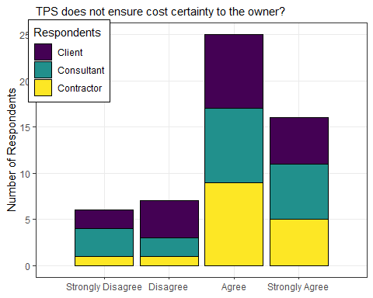

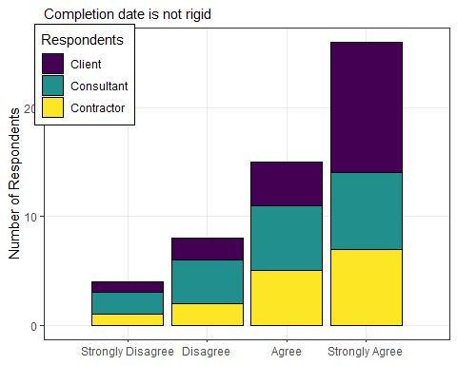

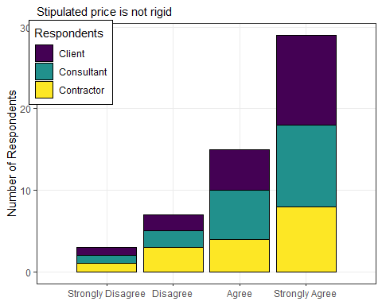

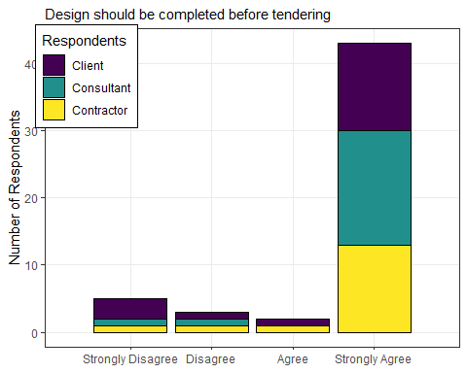

From Table 4.8 and figures 4.5 above the following observation are made:

* 74.6% (n=44) of Professional Consultants, Contractor and Client agreed that TP does not ensure cost certainty to the owner. On the contrary 25.4% (n=15) disagree
* 71.8% (n=45) of Professional Consultants, Contractor and Client agreed that Completion date is not rigid. On the contrary 22.4% (n=13) disagree
* 81.3% (n=48) of Professional Consultants, Contractor and Client agreed that Stipulated price is not rigid. On the contrary 18.7% (n=11) disagree
* 86.2% (n=50) of Professional Consultants, Contractor and Client agreed that Design should be completed before tendering. On the contrary 13.8% (n=8) disagree
* 88.2% (n=52) of Professional Consultants, Contractor and Client agreed that Cost overrun due to new design and specification. On the contrary 11.8% (n=7) disagree
* 81% (n=47) of Professional Consultants, Contractor and Client agreed that Cost overrun due to quantities and variation of price factors. On the contrary 19% (n=11) disagree
* 81.4% (n=48) of Professional Consultants, Contractor and Client agreed that Responsibility of design is vested to the Client. On the contrary 18.6% (n=11) disagree
* 89.6% (n=52) of Professional Consultants, Contractor and Client agreed that Design changes impact price. On the contrary 10.4% (n=6) disagree
* 79.7% (n=47) of Professional Consultants, Contractor and Client agreed that Dispute occur between the owner and Contractor. On the contrary 20.3% (n=12) disagree

**4.4 Presentation of Findings - challenges that hinder the Client to move from Traditional procurement system to Design and Build procurement system**

The third issue addressed by the questionnaire was to determine the challenges that hinder the Client to move from Traditional procurement system to Design and Build procurement system on roadworks project in Tanzania. Section D has eighteen statements aimed at providing data to answer this Research Question. Their responses were recorded in Table 4.9 as shown below:-

|  |  |  |  |  |  |  |
| --- | --- | --- | --- | --- | --- | --- |
| **S/No** | **STATEMENTS** | **Very**  **Low** | **Low** | **Moderate** | **High** | **Very**  **High** |
| 1. | Lack of design expertise | 13 | 7 | 3 | 4 | 5 |
| 2. | Lack of interest from owners | 7 | 11 | 15 | 15 | 9 |
| 3. | Lack of suitable organisation structure | 7 | 9 | 16 | 14 | 11 |
| 4. | Lack of Design and Build specialist | 6 | 4 | 13 | 16 | 19 |
| 5. | Lack of design-build experience | 3 | 3 | 11 | 15 | 26 |
| 6. | Unfamiliarity of owners | 6 | 5 | 10 | 21 | 16 |
| 7. | Lack of support from local government | 12 | 9 | 11 | 15 | 11 |
| 8. | Lack of competent design-builders | 1 | 7 | 16 | 14 | 14 |
| 9. | Uncertainty of design-build contract | 8 | 5 | 11 | 25 | 7 |
| 10. | Higher risk of design-build projects | 8 | 8 | 14 | 16 | 12 |
| 11. | Lack of qualification regulations | 7 | 11 | 10 | 14 | 15 |
| 12. | Effectiveness of design-build projects | 9 | 17 | 16 | 13 | 3 |
| 13. | Difficulty in writing design-build request for proposals | 14 | 12 | 15 | 11 | 5 |
| 14. | Lack of Contractor selection methods | 17 | 12 | 17 | 9 | 2 |
| 15. | Higher Contract price of design-build projects | 8 | 13 | 14 | 13 | 10 |
| 16. | Conflict with existing bidding law | 15 | 9 | 17 | 6 | 9 |
| 17. | Coordination with Subcontractor | 18 | 18 | 14 | 4 | 3 |
| 18. | Lack of specified subcontractors | 22 | 16 | 13 | 4 | 5 |

The above-outlined responses has further been graphically presented for clarity in a bar charts as illustrated in Figure 4.6 below:

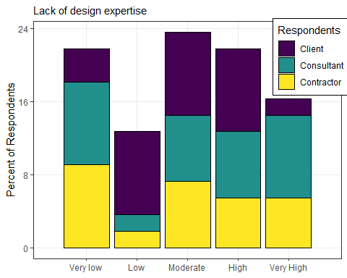

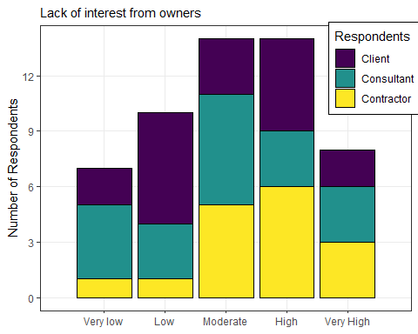

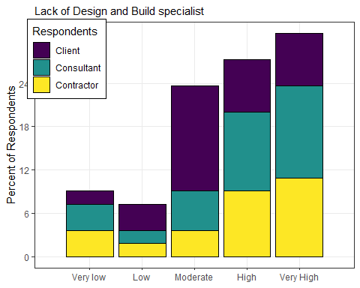

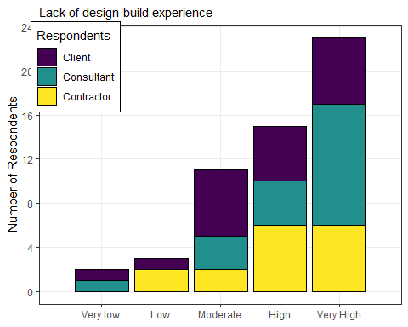

From Table 4.9 and figures 4.6 above the following observation are made:

* 63.7% (n=37) of Professional Consultants, Contractor and Client believe that Lack of design expertise hinder the Client to move from Traditional procurement system to Design and Build procurement system. On the contrary 36.3% (n=21) don’t believe
* 69% (n=40) of Professional Consultants, Contractor and Client believe that lack of interest from owners hinder the Client to move from Traditional procurement system to Design and Build procurement system. On the contrary 31% (n=18) don’t believe
* 70.7% (n=41) of Professional Consultants, Contractor and Client believe that lack of suitable organisation structure hinder the Client to move from Traditional procurement system to Design and Build procurement system. On the contrary 29.3% (n=17) don’t believe
* 81.3% (n=48) of Professional Consultants, Contractor and Client believe that lack of Design and Build specialist hinder the Client to move from Traditional procurement system to Design and Build procurement system. On the contrary 18.7% (n=11) don’t believe
* 88.1% (n=52) of Professional Consultants, Contractor and Client believe that lack of design-build experience hinder the Client to move from Traditional procurement system to Design and Build procurement system. On the contrary 13.3% (n=8) don’t believe
* 80% (n=48) believe that unfamiliarity of owners hinder the Client to move from Traditional procurement system to Design and Build procurement system. On the contrary 20% (n=12) don’t believe
* 63.3% (n=38) of Professional Consultants, Contractor and Client believe that lack of support from local government hinder the Client to move from Traditional procurement system to Design and Build procurement system. On the contrary 36.7% (n=22) don’t believe
* 76.2% (n=43) of Professional Consultants, Contractor and Client believe that lack of competent design-builders hinder the Client to move from Traditional procurement system to Design and Build procurement system. On the contrary 23.8% (n=14) don’t believe
* 75.9% (n=44) of Professional Consultants, Contractor and Client believe that uncertainty of design-build contract hinder the Client to move from Traditional procurement system to Design and Build procurement system. On the contrary 24.1% (n=14) don’t believe
* 71.6% (n=43) of Professional Consultants, Contractor and Client believe that higher risk of design-build projects hinder the Client to move from Traditional procurement system to Design and Build procurement system. On the contrary 28.3% (n=17) don’t believe
* 67.7% (n=40) of Professional Consultants, Contractor and Client believe that lack of qualification regulations hinder the Client to move from Traditional procurement system to Design and Build procurement system. On the contrary 32.3% (n=19) don’t believe
* 55% (n=33) of Professional Consultants, Contractor and Client believe that effectiveness of design-build projects hinder the Client to move from Traditional procurement system to Design and Build procurement system. On the contrary 45% (n=27) don’t believe
* 52.5% (n=31) of Professional Consultants, Contractor and Client believe that Difficulty in writing design-build request for proposals hinder the Client to move from Traditional procurement system to Design and Build procurement system. On the contrary 47.5% (n=28) don’t believe
* 47.5% (n=28) of Professional Consultants, Contractor and Client believe that Lack of Contractor selection methods hinder the Client to move from Traditional procurement system to Design and Build procurement system. On the contrary 52.5% (n=31) don’t believe
* 63.3% (n=38) of Professional Consultants, Contractor and Client believe that higher Contract price of design-build projects hinder the Client to move from Traditional procurement system to Design and Build procurement system. On the contrary 36.7% (n=22) don’t believe
* 56.9% (n=33) of Professional Consultants, Contractor and Client believe that conflict with existing bidding law hinder the Client to move from Traditional procurement system to Design and Build procurement system. On the contrary 43.1% (n=25) don’t believe
* 37.3% (n=22) of Professional Consultants, Contractor and Client believe that Coordination with Subcontractor hinder the Client to move from Traditional procurement system to Design and Build procurement system. On the contrary 62.7% (n=37) don’t believe
* 32.2% (n=19) of Professional Consultants, Contractor and Client believe that lack of specified subcontractors hinder the Client to move from Traditional procurement system to Design and Build procurement system. On the contrary 67.8% (n=40) don’t believe

**4.5 Presentation of Findings - ways of which Design and Build procurement system can be used to reduce/eliminate current cost escalation on roadworks project in Tanzania**

The fourth issue addressed by the questionnaire was to determine the ways of which Design and Build procurement system can be used to eliminate current cost escalation on roadwork projects in Tanzania. Section E has eight statements aimed at providing data to answer this Research Question. Their responses were recorded in Table 4.10 as shown below:-

|  |  |  |  |  |  |  |
| --- | --- | --- | --- | --- | --- | --- |
| **S/No** | **STATEMENTS** | **Very**  **Low** | **Low** | **Moderate** | **High** | **Very**  **High** |
| 1. | Fixed Construction cost from the beginning of the project | 4 | 7 | 7 | 16 | 26 |
| 2. | Cost is minimized due to shortening of project duration by engaging D&B Contractor during design stage. | 2 | 4 | 13 | 23 | 17 |
| 3. | Fixed schedule due to absence of design errors, design omission | 4 | 6 | 18 | 20 | 12 |
| 4. | Schedule reduction and promote fast-tracking. | 3 | 3 | 14 | 25 | 14 |
| 5. | Claims are reduced since design errors and omission are responsibility of the Contractor. | 0 | 4 | 8 | 19 | 29 |
| 6. | Promote constructability and innovations as it inject the Contractor knowledge from designing stage | 0 | 2 | 9 | 27 | 22 |
| 7. | Quick delivery method as it allows the overlapping of Design and Construction process. | 1 | 1 | 10 | 26 | 22 |
| 8. | Design errors are minimized hence no increase in project cost | 1 | 4 | 13 | 20 | 22 |

The above-outlined responses has further been graphically presented for clarity in a bar charts as illustrated in Figure 4.7 below:

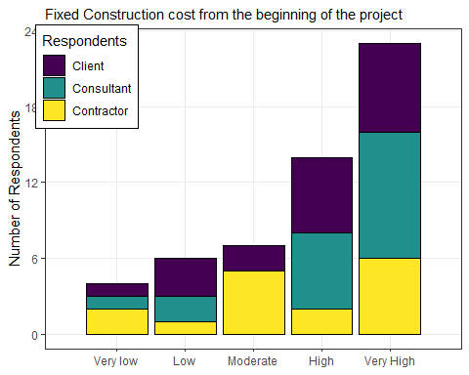

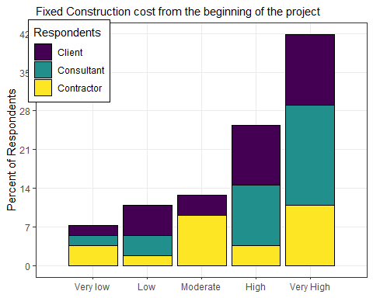

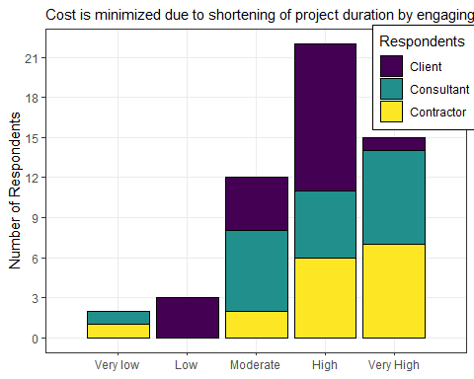

From Table 4.10 and figures 4.7 above the following observation are made:

81.7% (n= 49) of Professional Consultants, Contractor and Client believe that Design and Build procurement system can reduce cost escalation on roadworks project due fixed Construction cost from the beginning of the project. On the contrary 18.4% (n=11) don’t believe

88.3% (n=53) of Professional Consultants, Contractor and Client believe that Design and Build procurement system can reduce cost escalation on roadworks project since cost is minimized due to shortening of project duration by engaging D&B Contractor during design stage. On the contrary 11.7% (n=11) don’t believe

83.3% (n=50) of Professional Consultants, Contractor and Client believe that Design and Build procurement system can reduce cost escalation on roadworks project through fixed schedule due to absence of design errors, design omission. On the contrary 16.7% (n=10) don’t believe

89.8% (n= 53) of Professional Consultants, Contractor and Client believe that Design and Build procurement system can reduce cost escalation on roadworks project due to Schedule reduction and promote fast-tracking. On the contrary 10.2% (n=3) don’t believe

93.3% (n= 56) of Professional Consultants, Contractor and Client believe that Design and Build procurement system can reduce cost escalation on roadworks project since Claims are reduced since design errors and omission are responsibility of the Contractor. On the contrary 6.7% (n=4) don’t believe

96.7% (n= 58) of Professional Consultants, Contractor and Client believe that Design and Build procurement system can reduce cost escalation on roadworks project since it promotes constructability and innovations as it inject the Contractor knowledge from designing stage. On the contrary 3.3 % (n=2) don’t believe

96.7% (n=58) of Professional Consultants, Contractor and Client believe that Design and Build procurement system can reduce cost escalation on roadworks project since it is Quick delivery method as it allows the overlapping of Design and Construction process. On the contrary 3.3 % (n=2) don’t believe

91.7% (n=55) of Professional Consultants, Contractor and Client believe that Design and Build procurement system can reduce cost escalation on roadworks project since design errors are minimized hence no increase in project cost. On the contrary 8.3 % (n=5) don’t believe